Photo Copyright for WDP 2014

IMPORTANT: New Copyright Conditions

The photos and the original text were prepared by the WDP Committee of Germany. The text has been adapted. WDPIC has been given permission for the use of the photos and text by WDP National Committees. For permission to reproduce these images, please contact WDPIC. If used in printed materials, proper copyrights must be acknowledged.

These photos may NOT be used on WDP National Committee websites or made available for download.

Number/Title | ICON | Neccessary copyright information
1 Map | 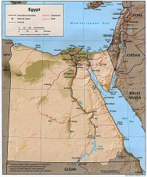
2  Aswan High Dam |  | ©Christel Selbach
3  Mount Sinai St. Catherine’s Monastery | 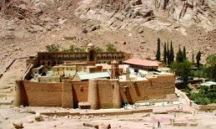 | © Biblische Reisen GmbH, Stuttgart
4  Bedouins and Tourism | 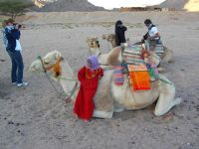 | © Heidi Henning
5  Cairo: City View |  | ©Jürgen Reichmann,  www.erde-in-bildern.com
6  Cairo: historic Islamic district |  | © Claudia Mende, www.claudia-mende.de
7  Cairo: Informal settlement |  | © Claudia Mende, www.claudia-mende.de
8  Tourism |  | © Heiner Heine
9  Cotton Production | 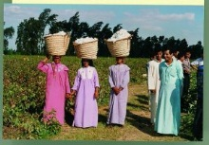 | © hessnatur
10  Saleswoman with little shop on the streets |  | © Heiner Heine
11  Sewing training | 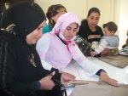 | © AUEED
12  Transport on the Nile | 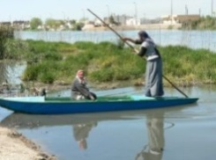 | © MISEREOR e.V./Abt. Afrika/Naher Osten
13  Polluted Nile Canal |  | © Heiner Heine
14  A woman drawing water | 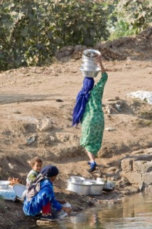 | © MISEREOR e.V./Abt. Afrika/Naher Osten
15  Using Nile water for farming-HEINE | 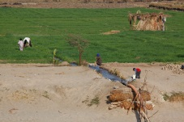 | © Heiner Heine
16  Cartoon: Neqab and a kite | 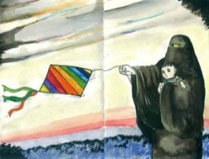 | © Mona Said
17  Al-Azhar mosque | 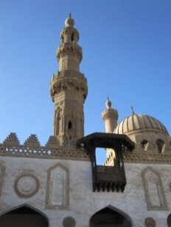 | © Renate Ehmer
18  Woman wearing niqab |  | © Christel Selbach
19  Prayer during protest | 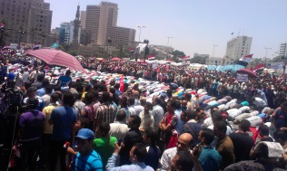 | © World Student Christian Federation
20  Bread for Eucharist in Coptic church |  | © Christel Selbach
21  Monastery St. Anthony | 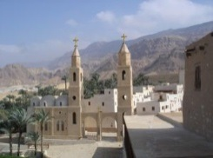 | © Christel Selbach
22  Mother Superior/Coptic Nun | 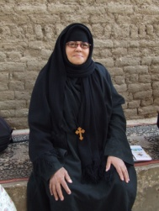 | © Bärbel Haug
23  Holy family as refugees in Egypt | 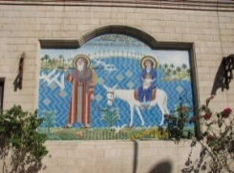 | © Gudrun Strobel
24  Giza pyramid complex | 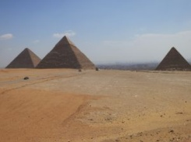 | © Friedgard Marquardt
25  Hieroglyphics on a  Pyramid’s wall | 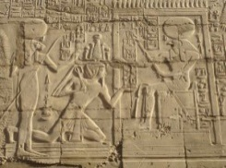 | © Renate Ehmer
26  Temple of Hatshepsut in Luxor | 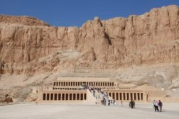 | © Heiner Heine
27  Sphinx | 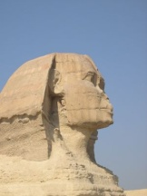 | © WGT e.V.
28  Citadel | 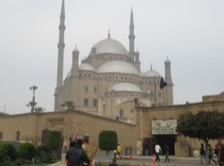 | © Marianne Klett, Ravensburg
29  Ships in Suez Canal | 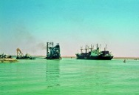 | © Claudia Mende, www.claudia-mende.de
30  Political Protest | 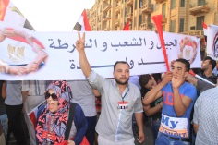 | © World Student Christian Federation
31  Tahrir Square Protests | 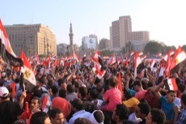 | © World Student Christian Federation
32  Graffity at Tahrir Square | 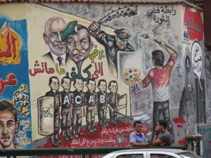 | © Eva Reiß
33  Female Protestors at Tharir Square | 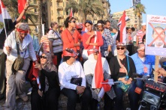 | © World Student Christian Federation
34  Poster encouraging women to go to the polls | 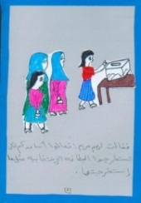 | © MISEREOR e.V./Abt. Afrika/Naher Osten
35  Campaign against Female genital mutilation | 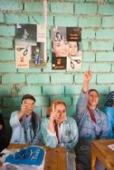 | © Achim Pohl, www.achim-pohl.de
36  Graffity: No to Violence against Women | 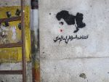 | © Claudia Mende, www.claudia-mende.de
37  Hoda Badran |  | © Claudia Mende, www.claudia-mende.de
38  Nawal el-Saadawi |  | © Franziska Gruber, TERRE DES FEMMES
39  Saleswoman with little shop on the streets |  | © Heiner Heine
40  Students |  | © Claudia Mende, www.claudia-mende.de
41  Elderly woman at political protest | 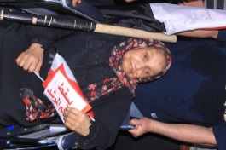 | © World Student Christian Federation
42  Women involved in political processes |  | © FriedensFrauenWeltweit
43  Women baking bread | 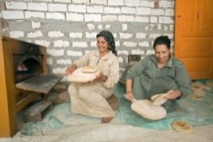 | © MISEREOR e.V./Abt. Afrika/Naher Osten
44  Rawia Abdel Kader |  | © Claudia Mende, www.claudia-mende.de
45  Basma Abdel Aziz | 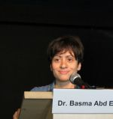 | © FAM
46  Karima Kamal |  | © Claudia Mende, www.claudia-mende.de
47  Hoda Lutfi |  | © Claudia Mende, www.claudia-mende.de
48  Media: Girls Radio | 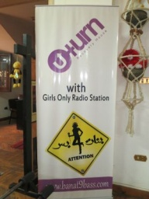 | © Friedgard Marquardt
49  Book fair in Cairo/Exhibition stand of Bible Society | 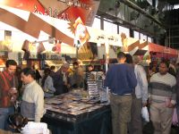 | © Heidi Josua
50  Hip Hop artists | 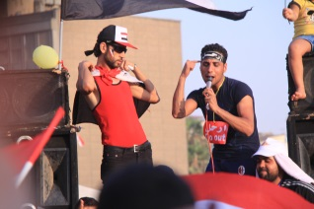 | © World Student Christian Federation
51  The importance of family |  | © Claudia Mende, www.claudia-mende.de
52  Apartment complex | 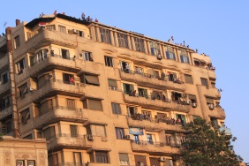 | © World Student Christian Federation
53  Poverty in the villiages | 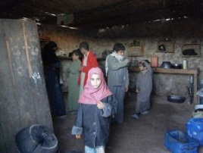 | © Heidi Henning
54  Heavy traffic in Cairo |  | © Heiner Heine
55  Transport in rural area: farmer with donkey | 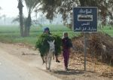 | © Ute Haizmann
56  Literacy program |  | © AUEED
57  Teacher | 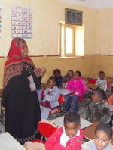 | © Heidi Henning
58  Waiting in front of a bakery for subsidized bread |  | ©Heiner Heine
59  WDP Artwork | 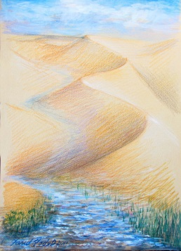
60 | 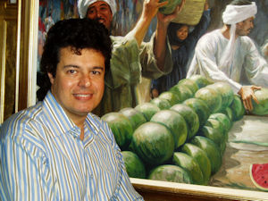
61  WDP Egypt | 