**WORLD DAY OF PRAYER**

**Prepared by the Cuban WDP Committee**

**March 4th, 2016**

**“Receive children. Receive me.”**

**Background Country Information with Photo, Caption, and Copyright**

1. **Map**

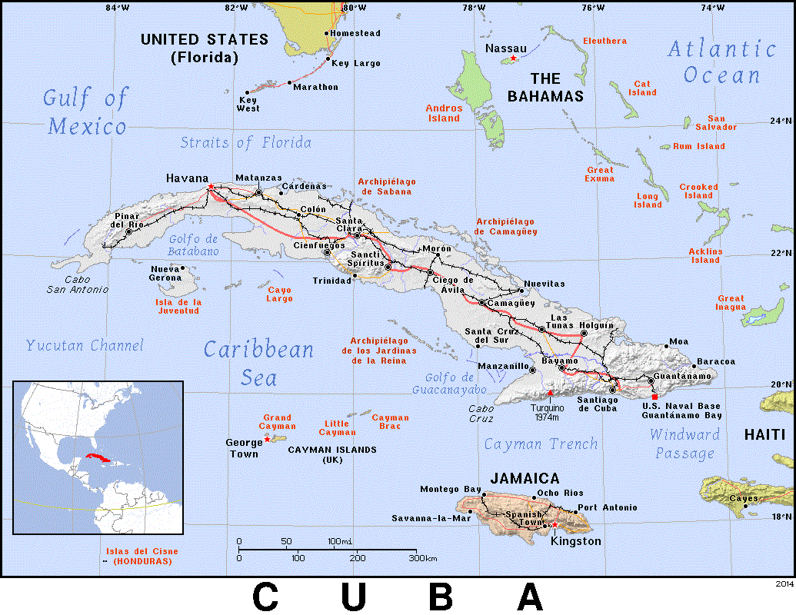Cuba is an indigenous word which means “cultivated land.” It is comprised of 4,195 islands, cays and islets of various sorts, including many that are covered only by mangrove. It spans a surface area of 110,860 km2, and is the largest Caribbean island located at the entrance of the Gulf of Mexico, and is therefore called “the key of the Gulf”.

1. **Shape of a Caiman**

Rebeca Cascante© La Habana, WDPIC©

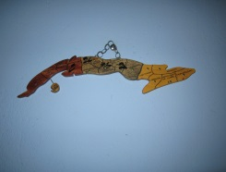 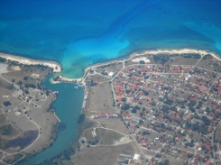

The Republic of Cuba is a beautiful, green archipelago in the shape of a caiman (alligator). It has a population of 11,116,000 persons.

1. **The Capital, La Habana**

La Habana, WDPIC© Gran National Theater, WDPIC©

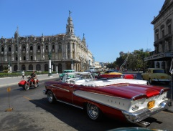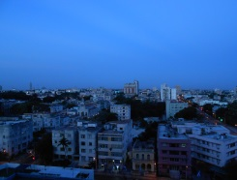

The capital is La Habana, today with approximately 2 million inhabitants. Founded in its present location in the year 1519, in 1553 it became the principal center of the country’s political, economic, cultural and social life.

1. **Population**

R. Trujillo© Carnival, WDP Cuba© R. Trujillo©

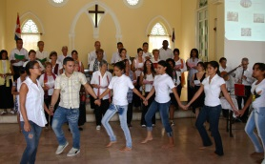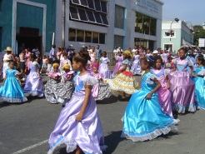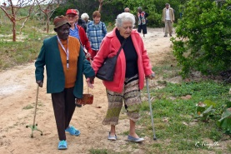

The native Arawaks from Venezuela and Guyana crossed the Caribbean Sea and settled here because of the fertility of the soil. With the onset of Spanish expeditions to this continent in search of wealth in the XV century and the transatlantic slavery trade from Africa in the XVI century, a web of relationships was being formed among families and the emerging society, giving rise to the term “criollo” - men and women, born on Cuban soil.

According to the National Census of 2012, 64.1% of the population was self-classified as white skin, 9.3% black and 26.6% mestizo. This data makes Cuba the second country with the largest black and mestizo population (35.9%) in Latin America, after Brazil with 45%, Colombia (11%) and Ecuador (5%).

The statistic indicates a decline in birth and population growth rates. There is an increase in emigration and an increase in the population aged 65 years and over. Life expectancy is 77 years for men and 80 for women.

1. **National Symbols**

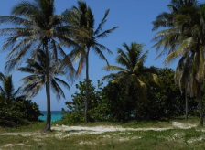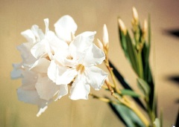White Butterfly Jasmine, WDP Cuba© Cuban flag, WDPIC© Palm Real, WDPIC©

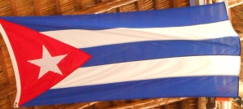

The official and only language of Cuba is Spanish. The national symbols are the Flag of the Solitary Star, the Anthem of Bayamo, and the National Coat of Arms. The trogon is the National Bird of Cuba, and the royal palm, is the National Tree of Cuba *.*The National Flower of Cuba is the white butterfly jasmine. Our women have used it in days gone by, not only as an adornment for their hair, but also to transmit messages during liberation wars, and as a sign of their being Cuban.

1. **Climate**

R. Trujillo© Rebeca Cascante© Rebeca Cascante© WDPIC© 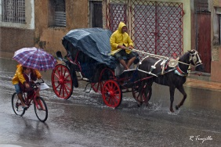 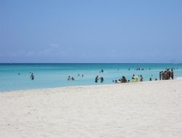 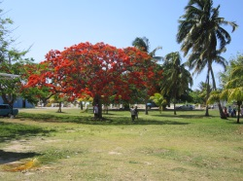 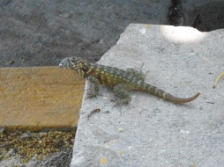

The climate is warm, humid subtropical, with an average temperature of 25.5°C. The flora is rich and diverse. The UNESCO declared the wetland of the Ciénaga de Zapata a Biosphere Reserve.

1. **Colonization**

Castle of the Royal Force, Rebeca Cascante© The Morro Fortress, WDP Cuba©

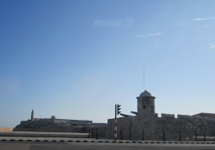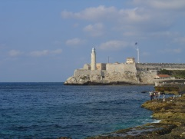

In 1492, Christopher Columbus reached this island, where he found a native population, possibly the Arawaks. Many of the indigenous peoples rebelled against the Spanish colonizers. Among them was Hatuey, an indigenous leader who was burnt alive in 1512. In October 10, 1868, Carlos Manuel de Céspedes freed his slaves, and the first struggle against Spanish colonialism was initiated. This is known as the “Ten Year War”; however, it did not fulfill the aspirations of seeing Cuba free of Spain.

The autochthonous population was submitted to hard work in slave-like conditions by the Spanish colonizers, resulting in their gradual and almost complete extinction. They were therefore replaced by large numbers of slaves who were bought in from various parts of Africa. The slaves also rebelled many times, and some of them were able to hide in the mangles, creating what is known as ‘cimarrones’- settlements of free slaves with their wives and children.

1. **Independence**

Jose Martí Mausoleum, WDPIC© Jose Martí, WDPIC©

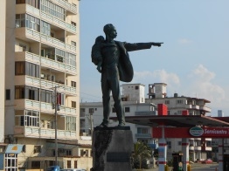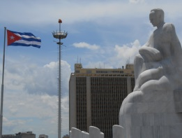

José Martí, Antonio Maceo, and Máximo Gómez started a second conflict in 1895, known as the “War of Independence”. The end of the war with Spain was mediated by the government of the United States of America, which secured its interests in the process of rupture with Spanish colonialism.

In 1902, the Republic of Cuba was constituted and the nation was organized, though conditioned by the “Platt Amendment”, which gave the United States the right to intervene in the internal matters of the island whenever they thought it was convenient.

In 1934, due to the pressure of labour and student movements, this law was abolished by a new treaty between the two governments which repealed the United States’ right to “intervene”, although the rights over the Guantánamo Naval Base were maintained by lease. Even today, this piece of national territory remains under the control of the North American government, in spite of reiterated demands of the Cuban government and the support of various countries, that this area be returned to the Cuban people. The Guantánamo Base, the largest naval base in the Caribbean, is also the site of a detention center ranked among the world’s prisons that most violates human rights.

1. **Revolution**

Revolution Square, Che Guevara, WDPIC© Revolution Square, Camilo Cienfuegos, WDPIC©

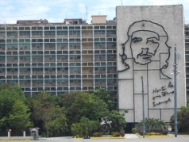 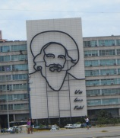

In the 1950s, a dictatorship devastated the most humble and vulnerable of Cuban society at the time, and poverty became widespread. A new movement, formed under the leadership of Fidel Castro Ruz, started what is known as the National Liberation War and, after innumerable attempts, triumphed on January 1, 1959. Fidel Castro was accompanied by other leaders, such as Ernesto Che Guevara, Camilo Cienfuegos, Celia Sánchez Manduley, Haydée Santamaría, Melba Hernández, and Vilma Espín.

Since 1961, the Republic of Cuba has maintained a democratic socialist government, led by the National Assembly of People’s Power. This Assembly holds elections every five years, and any citizen may nominate their grassroots candidate. The National Assembly of People’s Power is in charge of ensuring compliance with the Constitution of the Republic, its legislations and projects. Since 2008, Raúl Castro Ruz has been the president, and he is also the First Secretary of the Central Committee of the Communist Party of Cuba.

1. **Social Impacts of the Revolution**

Viñales Valley, Pinar del Río, WDP Cuba© WDP Cuba© WDP Cuba© 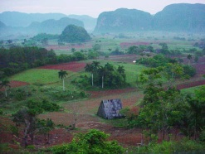 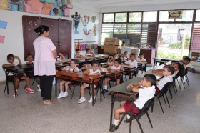 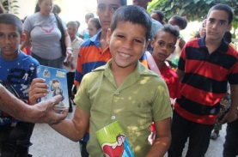

The triumph of the Revolution became the starting point for the history of the most disadvantaged sectors: peasants, workers, children, women, and the poorest of the population. Illiteracy was eliminated, large companies and foreign monopolies were nationalized, and large estates were eliminated by the Law of Agrarian Reform, which divided the land among the peasants. Public health was offered to the whole population, and the people’s dignity was restored.

Education and culture are very strong values in Cuba, as well as the improvement of the quality of life of its people, especially, the elderly, women, and children.

1. **Special Period**

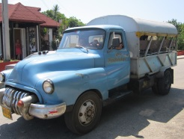Rebeca Cascante© Rebeca Cascante©

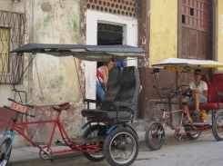

The Cuban Revolution, which was supported politically and economically by the countries of the “socialist block”, diverted more and more towards Marxist-Leninist ideology. Consequently, the fall of the “Berlin wall” in 1989 and the great political and economic change among socialist countries put Cuba in a deep crisis. Cuba lost the help she used to receive in important areas such as food, transportation, fuel, domestic items, medicines, etc. This was the start of what Cubans call the “Special Period”, a time characterized by the worsening shortage of basic necessities, intensified by the embargo that the United States government has maintained over the country since the triumph of the Revolution in 1959.

1. **The Commercial and Financial Blockade**

WDP Cuba© Pastors for Peace, Caravan to Cuba, WDP Cuba©

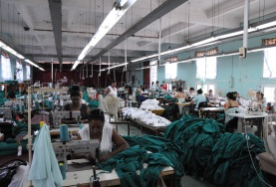 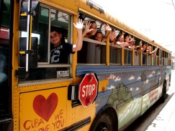

The commercial, economic and financial embargo of the North American government on Cuba began in 1960, and the breakdown of diplomatic relations in 1961. The embargo is clearly manifested in the shortage of raw materials and other resources required for industry, like the production of medicines and food.

The humanitarian and social impact of the embargo has affected all spheres of life of the Cuban people, including the churches and family relationships. Close to 70% of the Cuban population was born under the embargo. More than 50 years later, it continues to be said that the embargo is humanitarianly unjust for the whole Cuban people.

On December 17, 2014, both governments, under President Raul Castro in Cuba and Barak Obama in the USA, announced the re-establishment of diplomatic relations interrupted by the blockade. In his speech in Cuba, Raul Castro gratefully acknowledged the support of the Vatican, Pope Francis, for the change of relations between Cuba and the United States.

The announcement was followed by the government of Cuba releasing an American prisoner in Cuba, Alan Gross, and the US government releasing three Cubans from the group known as 'The Five', who were still imprisoned in the US - Gerardo Hernández, Antonio Guerrero and Ramon Labaniño. Other political dissidents in Cuba have also been released since the announcement, including relatives of the Ladies in White.

By April 2015, the government delegations led by the Cuban Josefina Vidal and the American Roberta Jacobson, had a series of talks on re-establishing the diplomatic ties. The negotiations include economic trade, travel permission, telecommunication policies, maritime border and human rights.

1. **New Changes in the Economy**

Varadero Beach, Rebeca Cascante© Varadero Beach, WDPIC©

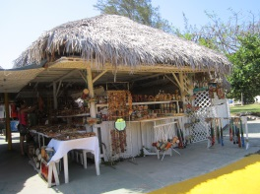 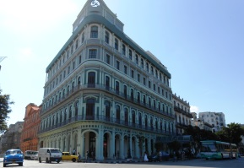 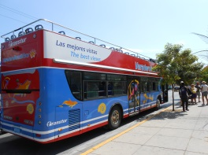 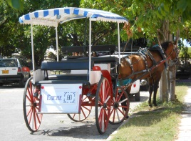

Gran Caribe Hotel, La Habana, WDPIC© Varadero Beach, WDPIC©

As it occurs in the rest of the world, Cuba faces a difficult economic crisis in which it struggles to maintain the benefits achieved by the people. New measures were taken to guarantee the growth of the economic resources such as international tourism, co-operative movement, and small private businesses. Those are significant changes in Cuba society which contribute to solve some of the most crucial problems of its people.

1. **Social Challenges**

R. Trujillo© WDP Cuba© WDP Cuba©

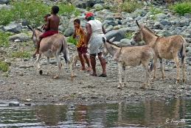 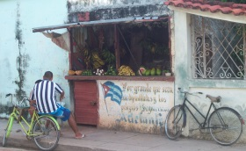 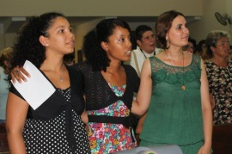

Family life has been affected by many shortages noted in the daily life. There is discontentment, inconformity and violence. Sons and daughters are worried by their continued economic dependence on parents. The female heads of households bear a situation of anxiety and uncertainty, which at times they do not know how to resolve. Another challenge the Cuban family currently faces is the aging of the population, coupled with the emigration, mainly of younger persons, to developed countries.

Midiam Lobaina, coordinator of the Gender Programme of the Council of Churches of Cuba, discussed the reproduction of racist stereotypes in families, along with the feminist group known as Afrocubanas during the Tertulia Reyitas Debates. Midiam pointed out that families create mechanisms of tolerance to racist practices, and it is important to recognize racist behavior and practices that discriminate the afro-descendent families.

1. **Children**

R. Trujillo© Baseball field, WDPIC© R. Trujillo©

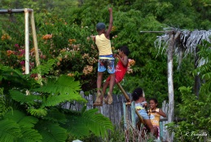 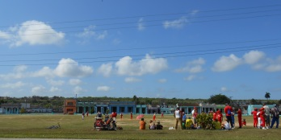 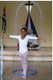

“Nothing is more important than a child,” is a very popular phrase in Cuba. Free education and free health services are guaranteed for children. They also have access to healthy food, security for their recreation, and physical and emotional support, even though the Cuban people are facing economic difficulties.

Cuba was among the first countries to ratify the Convention on the Rights of the Child (1991) despite the set of laws that already protected childhood. The UNICEF office in Cuba reported the infant mortality rate to have dropped from 11 to 4.2%, and that the transmission of HIV/AIDS in the mother-to-child ratio is controlled. In addition, Cuba had eliminated severe child malnutrition, though there are still some pockets in neighborhoods of Habana and the eastern provinces.

At the beginning of the year 2015, almost half a million children from 30 days old to two years were immunized by the National Anti-polio vaccination campaign. The campaign involves sectors of the medical area, women and communities. Polio was eliminated in Cuba since 1962.

The third Sunday of July, Cuba celebrates Children’s Day throughout the country with many parties in the parks and churches.

1. **The Youth**

WDP Cuba© WDP Cuba© WDP Cuba©

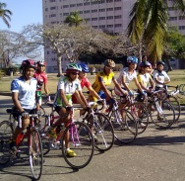 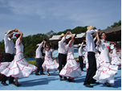 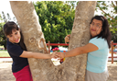

According to the National Youth Survey 2012, the young male population between 20 and 24 years is slightly higher than the female. Among the youth population, 42.5 percent work; 32.5 study, while 7 percent share both activities and 7.7 percent do housework. Among the youth group of 18-24 years, 30.4 percent has higher education. Among young workers, 49.5 percent are men and 35.3 percent are women. While in the household work, women comprise 13.7 percent and men 0.06 percent.

1. **Housing**

Rebeca Cascante© Old Habana, Rebeca Cascante© Rebeca Cascante©

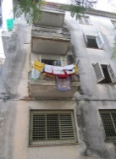 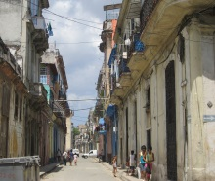 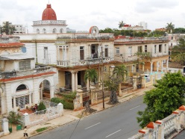

The mansions were once a one family house, but today are shared by several families. Different generations live together in one house. Grandparents, parents, children and grandchildren reside under one roof. Although culturally the extended family is valued in Cuba, lack of housing for new marriages has affected family independence. Different housing construction plans have been implemented, but have been insufficient, and families do not have the financial resources needed to build a house.

1. **Education**

R. Trujillo© R. Trujillo© WDPIC© WDP Cuba©

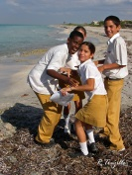 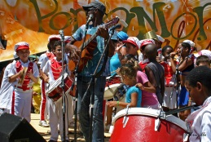 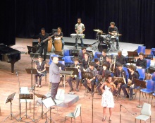 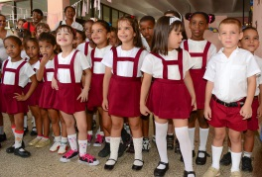

The educational system was structurally organized in 1522, when the first schools for primary education were opened. In the 1700s, important educational centers were founded, but until 1959 there were only three Universities in the country, and illiteracy was growing.

After the triumph of the Revolution, the “Literacy Campaign” was carried out in 1961. Since then, all types of schools were opened, from primary to specialized, technical and university levels. Today there is currently a University Campus in each municipality, providing opportunities to study free of charge for all who desire. The Medical Schools are very well attended in the country, especially by women.

1. **Health**

WDP Cuba© Pharmacy, WDP Cuba©

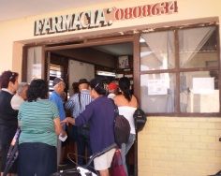 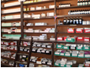

The health services are offered at different levels; from primary health care in the area of residence, to secondary care in hospitals and tertiary care in Specialty Institutions. One of the principles of Cuban medicine is that each individual who requires medical attention is treated free of charge.

Sexual and reproductive health includes the essential right of the woman to assume control and make decisions concerning her body and sexuality. Careful attention is paid to all transmissible infections that are not yet vaccine-preventable, including HIV/AIDS.

Cuba is the country with the most doctors per inhabitant. Doctors and other health specialists and technicians travel as collaborators to various countries, offering service in places where no doctor had ever been before. In 2014, medical personnel were sent to Liberia and Sierra Leone to participate in the fight against Ebola epidemic.

1. **Climate Change**

(All four photos) - Hurricane Sandy, Santiago de Cuba, Centro B. G. Lavastida©

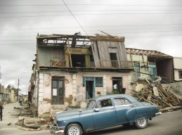 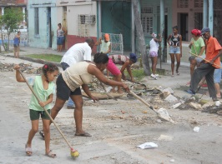 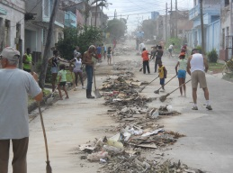 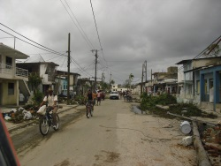

The damages caused by climate change are already evident on the coast of Cuba, especially in the lowlands. One of the evidences of sea level rise is the modification of mangrove forests and retreat of the coastline at the rate of several meters, both on the beaches and wetlands.

The Meteorological Institute of Cuba has mapped overall prognosis of coastal flooding and storm surges, which are valid for the current conditions. It is obvious that these same stretches of coastline will be affected more strongly to the extent that sea level rises in the coming years.

The beaches are also places where wave energy is dissipated, but the rise in sea level tends to modify and can eventually destroy them.

Hurricane Sandy hit the city of Santiago de Cuba in October 2012. It was a challenge for Lavastida Center to service the community. Various churches and both civil and ecclesiastical organizations joined forces to give immediate response to the situation and then to assist in the reconstruction of the city. This alleviated hunger during the first weeks and allowed for more extensive reconstruction. “As we approach the celebration of 500 years of the existence of our city,” says Gisela Perez, Director of the B. G. Lavastida Center, “we perceive that the effects of Sandy are minimal.”

1. **Culture**

WDPIC© WDPIC© R. Trujillo© Rebeca Cascante© 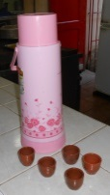 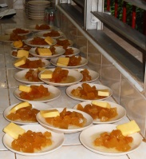 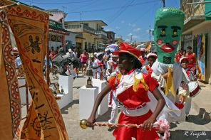 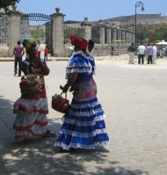

Cuban culture received the influence of the great mother cultures, specifically Spanish and African, as well as the heritage of the indigenous people. In music and dance, the culture highlights the punta, the rumba, the danzón, the danzonete, the mamba, the chachachá, the Cuban song and the guaracha. A very well-known song is “La Guantanamera,” attributed to José Fernández, with the verses based on the collection of the Versos Sencillos by José Martí, the “National Hero of Cuba.”

The percussion instruments used, including in the church celebrations, are the bongo, maracas, claves and tres.

The majority of Cuban families welcome their visitors with a cup of fragrant coffee. In Cuba, coffee is taken very strong, with sugar, and served in small cups.

1. **Religion**

Presbyterian Reformed Church in Cardenas, WDP Cuba© Episcopal Church, WDPIC©

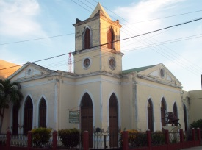 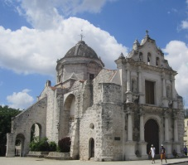 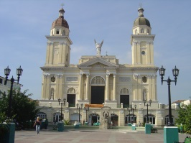 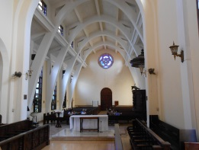

Rebeca Cascante© Santiago de Cuba Cathedral, WDP Cuba©

In Cuba, the profession of faith is a socio-spiritual component of the life of the people and forms a part of the culture, in spite of having passed through a period in which persons who practiced any religion were marginalized by the official atheist policy. As of the 1990s, the Constitution reestablished the lay character of the State and guaranteed religious freedom.

Of the Cuban faith traditions, the most deeply rooted religion is Christianity. The Roman Catholic Church arrived with the Spanish colonization in the fifteenth century. The Catholic patroness of Cuba is La Virgen de la Caridad del Cobre (Our Lady of Charity of El Cobre). The second half of the nineteenth century saw the arrival of various protestant or evangelical and orthodox churches. There is great popular acceptance of Afro-Cuban religions, which have their roots in the religiosity brought and cultivated by enslaved Africans. Islam, Judaism, Spiritualism and New Christian Religious Movements with fundamentalist tendencies are also present in Cuba, albeit in lesser proportions.

1. **Women and Churches**

WDPIC© WDPIC© WDP Cuba©

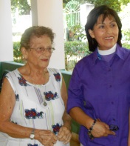 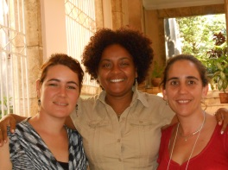 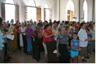

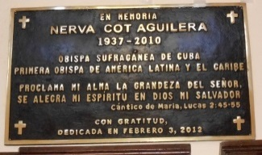 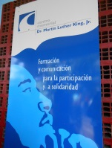 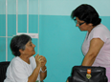

In honor of the Martin Luther King WDP Cuba (left) and CIC Women

first woman bishop, WDPIC© Ecumenical Center, WDPIC© and Gender Program (right)

coordinators, WDPIC©

In most Cuban congregations, women are pastors, missionaries, nuns, and laywomen. Many are ordained to holy ministry and have high-level responsibilities, such as the episcopacy of the Anglican or Episcopal Church of Cuba and the Pentecostal Holiness Church. Various Seminaries have had women deans. There is also a movement of women theologians that has been outstanding in the life of the church in Cuba.

The Cuban Council of Churches is a highly prestigious ecumenical institution that brings together most of the protestant denominations. Among its various programs is that of “Women and Gender”, which has developed strategies for the integral education of women and the family. Other institutions that also deal with this issue include the Christian Centre of Reflection and Dialogue, in Cárdenas, Matanzas; the B.G. Lavastida Center, in Santiago de Cuba; and the Gender Institute, in Matanzas and the Martin Luther King Memorial Center, in Habana.

**24. Afro-Cuban Women**

WDP Cuba©

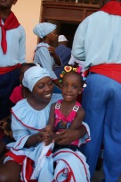The Revolution of 1959 created constitutional measures to eliminate racial segregation, such as equal access to employment, education and public services. However, signs of historical racism resulted from the colonization model still influence the behavior and social practices, even though slavery was abolished in 1886.

Statistical research is needed to display the status of each racial group, but there are sociological studies indicating that the black population receives less income, live in worse housing, and are less present in higher education. There is a growth in households headed by single women of African descent, who have fewer resources for subsistence. The economic reform process that creates the alternative of self-employment show signs of occupational segregation by skin color. And audiovisual media reinforce stereotypes where people of African descent are in negative roles.

Daysi Rubiera is a historian, founder of the feminist group AfroCubanas, and author of books including *Reyita, Sencillamente*. The book, using the testimony genre, narrates the story told by a black woman. Born at the beginning of the twentieth century, Reyita suffers the social consequences of being the granddaughter of a slave. Daysi Rubiera is an academic and social activist who advocates for recognition and transformation of social structures that maintain gender and race inequality in Cuba.

**25. Women and Politics**

Rebeca Cascante©

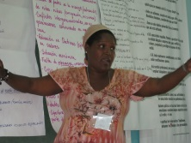Women are amply represented in the Constituent Assembly and make up 43.3% of delegates. And 29.5% of presidents of municipal governments are also women. According to the Inter-parliamentary Union, Cuba occupies 4th place in the world on the scale of countries with the most women in their Parliament.

Cuba stands out for having signed the main International Conventions of the United Nations (UN), such as the Convention on the Rights of Women and the Convention on the Rights of the Child, and for creating mechanisms for compliance throughout the whole country.

**26. Women and Work**

WDPIC© WDPIC© WDP Cuba© WDP Cuba©

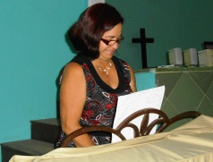 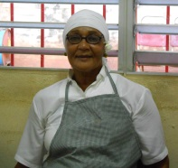 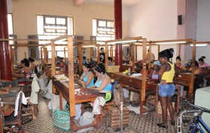 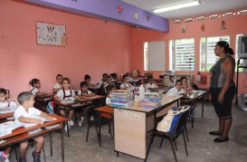

After the Revolution in 1959, women were incorporated as an active force in the construction of the new society, broadening the opportunities to improve their scientific-technical and professional training. In 1961, the Federation of Cuban Women (FCW) was formed by Vilma Espín. The FCW is composed of 4 million Cuban women from all professional categories.

In order to achieve the Federation’s objectives, a series of measures were proposed to lay the foundations for the satisfactory insertion of Cuban women into the labor force. Among them were the changes to the employment system and structure to allow women to overcome cultural, technical and professional obstacles and occupy posts traditionally assigned to men; changes in the Constitution of the Republic and the Labor Code to guarantee equal rights for men and women; and the creation of Daycare Centers for the children of working mothers. Today more than 46% of persons employed in the public sector are women; women constitute 68% of the technically and professionally qualified labor force and 39% are managers.

The Cuban woman plays an important role in the society, church and family, although she faces a long chain of suffering and discrimination. Today, there are still patterns of behavior that denote a patriarchal and male chauvinist culture at all levels of social relations.

**27. History of the World Day of Prayer in Cuba**

National Committee, WDP Cuba© Dora Valentín Lois Kroheler,

WDPIC© Dora Arce Valentín© Courtesy of Lois Kroheler

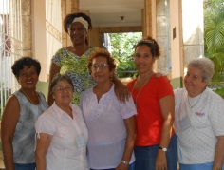 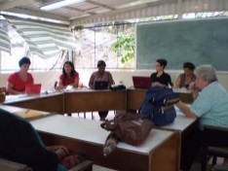 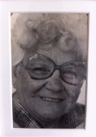 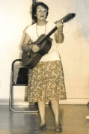

WDP Cuba (left) and WDPIC regional representative (right), WDPIC©

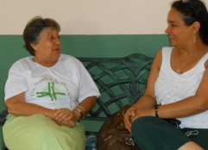

The first reference we have concerning the celebration of the World Day of Prayer (WDP) in Cuba dates back to the year 1930. The Reformed Presbyterian Church of Cuba celebrated it for the first time with a program sent by women from the United States of America. The Methodist Church celebrated the WDP for the first time on February 20, 1931, and in 1972 the Salvation Army was celebrating the WDP. These three denominations were the first to have direct contact with the World Day of Prayer, thanks to the fact that their counterparts in the United States sent the program directly to them.

In 1975, the International Year of the Woman, the Council of Evangelical Churches of Cuba organized its Women’s Department, and Sister Dora Valentín (1925-1992), of the Presbyterian Church, was elected as its first president. Lois Kroheler, the only United States Presbyterian missionary who stayed in Cuba after the triumph of the Revolution in 1959, and Dora Valentín, promoted the celebration of the World Day of Prayer. That is how the celebration of the WDP first spread throughout the protestant world, and then reached some of the Catholic parochial.

In 2011, a WDP Strengthening Workshop was held, during which the National WDP Committee was organized. Since then, this program is promoted by its Committee, although we continue to work closely with the Women and Gender Program of the Cuban Council of Churches. In the last few years, each first Friday of March, women and men, of over 30 denominations, come together over 20 locations throughout the country for prayer, reflection, unity, and action.

The Committee has been chaired by Ormara Nolla Cao, from the Fraternity of Baptist Churches of Cuba; Isis García Basulto, Secretary, Roman Catholic Church; Noemí Manrique Arango, Treasurer, Church of Christ; and Sandra Zaldívar Ferrer, for Program and Projects, Salvation Army. We have regional coordinators for eastern Cuba, Rosario Concepción Fernández, Church of Friends (Quakers), central region Amelia Pérez Muñiz, Eastern Baptist Convention, and for the western region Aleida Palacios Cuny, Apostolic Church of Jesus.

**28. Writing Committee for the World Day of Prayer 2016**

Rebeca Cascante© WDPIC© WDPIC© WDPIC© WDPIC©

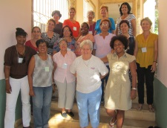 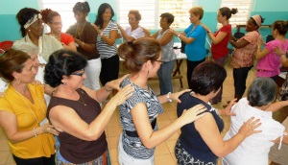 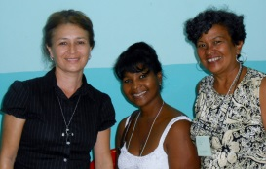 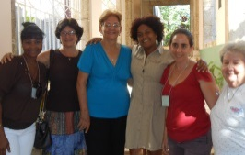 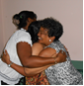

In 2013, the Preparatory Workshop was held in Cuba to launch the writing process. Together with more than 20 women members of the World Day of Prayer and resource persons from the ecumenical organizations in Cuba, they organized the writing working groups to develop the worship service and the educational resources for the celebrations for WDP 2016 with the theme, “Receive children. Receive me.”

**29. Artwork and Artist**

Ruth Mariet Trueba Castro© Ruth Mariet Trueba Castro©

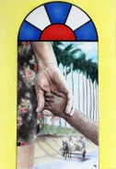 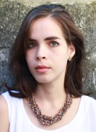

“The WDP theme suggests welcoming and openness. The image evokes a welcome door, a path, an openness to hope. We are on a permanent journey. These human beings, whom I imagined as a mother and a child, in the miscegenation of Cuban families, enjoy a walk in the countryside, which is also the concrete and living environment of many children in Cuba. Looking at the drawing in detail, we can reconsider the common misconception that any movement requires the adult to guide the child. Why do we hardly think that children can guide adults to show the universe? In truth, only Jesus is the guide for this side by side walk.” – Ruth Mariet Trueba Castro

Ruth Mariet Trueba Castro, the creator of *On the Threshold of Childhood*, lives in Jaimanitas, in the city of La Habana. She graduated from the Academy of Fine Arts San Alejandro, La Habana, 2009; and from the Instituto Superior de Arte (ISA); major in Plastic Arts, La Habana, 2014. She is a member of the Methodist Church in Jaimanitas, La Habana, Cuba. She is currently coordinating the Liturgical Renewal Program of the Cuban Council of Churches.

*For further information, contact:*

*World Day of Prayer International Committee*

*475 Riverside Drive Room 729.*

*New York, NY. 10115, USA*

[*admin@worlddayofprayer.net*](mailto:admin@worlddayofprayer.net)

[*http://worlddayofprayer.net*](http://worlddayofprayer.net)

*It is required that you include the copyright information when using the pictures in your materials.  Please be aware of the copyright laws of your country.

*Se requiere que usted incluya la información de derechos de autor al utilizar las imágenes y canciones en sus materiales. Por favor, esté al tanto de las leyes de copyright de su país.

* Il est obligatoire de mentionner le droit d'auteur lorsque vous utiliserez les chants et les photos dans votre matériel. N'oubliez pas de respecter les lois de droit d'auteur dans votre pays.